**Create a Power BI Dashboard**

**Lab story**

In this lab, you'll create the **Sales Monitoring** dashboard in the Power BI service using an existing report.

In this lab you learn how to:

* Pin visuals to a dashboard
* Use Q&A to create dashboard tiles

**This lab should take approximately 30 minutes.**

**Get started – Sign in**

In this task, you'll set up the environment for the lab by signing in to Power BI.

*Note: If you've already signed in to Power BI, skip to the next task.*

1. To open Microsoft Edge, on the taskbar, select the Microsoft Edge program shortcut.



1. In the Microsoft Edge browser window, navigate to **https://app.powerbi.com**.

*Tip: You can also use the Power BI Service favorite on the Microsoft Edge favorites bar.*

1. Complete the sign-in process with your organizational credentials (or those provided to you). If prompted by Microsoft Edge to stay signed in, select **Yes**.
2. In the Microsoft Edge browser window, in the Power BI service, in the **Navigation** pane, expand **My Workspace**. Leave the Microsoft Edge browser window open.

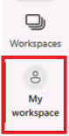

**Get started – Open report**

In this task, you'll set up the environment for the lab by opening the starter report.

*Important: If you're continuing on from the previous lab (and you completed that lab successfully), don't complete this task; instead, continue from the next task.*

1. Open Power BI Desktop.

*By default, the Getting Started dialog box opens in front of Power BI Desktop. Sign-in, and then close the pop-up.*



1. To open the starter Power BI Desktop file, select the **File > Open Report > Browse Reports**.
2. In the **Open** window, navigate to the **D:\PL300\Labs\09-create-power-bi-dashboard\Starter** folder, and open the **Sales Analysis** file.
3. Close any informational windows that may open.
4. Notice the yellow warning message beneath the ribbon. *This message alerts you to the fact that the queries haven't been applied to load as model tables. You’ll apply the queries later in the lab.*

*To dismiss the warning message, at the right of the yellow warning message, select****X****.*

1. To create a copy of the file, go to **File > Save As** and save to **D:\PL300\MySolution** folder.
2. If prompted to apply changes, select **Apply Later**.

**Get started – Publish the report**

In this task, you'll set up the environment for the lab by creating a dataset. *If you've already published the dataset, please move to the next task.*

1. In the Microsoft Edge browser window, in the Power BI service, navigate to **My Workspace**.
2. Select **Upload > Browse**.
3. Navigate to **D:\PL300\Labs\09-create-power-bi-dashboard\Starter** folder.
4. Select the **Sales Analysis.pbix** file, and then select **Open**.

*If prompted to replace the dataset, select****Replace it****.*

**Create a dashboard**

In this task, you'll create the **Sales Monitoring** dashboard. You'll pin a visual from the report, and add a tile based on an image data URI, and use Q&A to create a tile.

1. In the Power BI service, open the **Sales Analysis** report.
2. In the **Overview** page, set the **Year** slicer to **FY2020**.

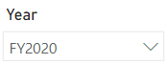

1. Set the **Region** slicer to **Select All**.

*Pinned visuals are set with the filter context at time of pin. If the underlying visual changes, you'll need to update the dashboard tile as well. For time-based filters, it’s a better idea to use a relative date slicer (or, Q&A using a relative time-based question).*

1. To create a dashboard and pin a visual, hover the cursor over the **Sales and Profit Margin by Month** (column/line) visual, and select the pushpin.

Picture 43

1. In the **Pin to Dashboard** window, in the **Dashboard Name** box, enter **Sales Monitoring**, then select **Pin**.

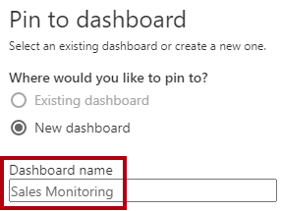

1. Open **My Workspace** and open the **Sales Monitoring** dashboard.
2. Notice that the dashboard has a single tile.

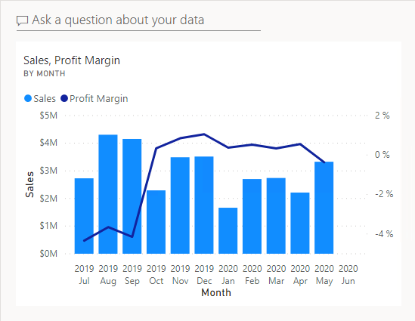

1. To add a tile based on a question, at the top-left of the dashboard, select **Ask a Question About Your Data**.

*You can use the Q&A feature to ask a question, and Power BI will respond will a visual.*

Picture 7

1. Select any one of the suggested questions beneath the Q&A box, in blue boxes, and review the response.
2. Remove all text from the Q&A box, and enter the following: **Sales YTD**
3. Notice the response of **(Blank)**.

*You may recall you added the****Sales YTD****measure in the****Create Advanced DAX Calculations in Power BI Desktop****lab. This measure is a Time Intelligence expression and it so requires a filter on the****Date****table to produce a result.*



1. Extend the question with: **in year FY2020**.
2. Notice the response is now **$33M**.

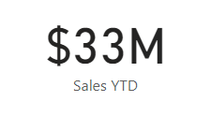

1. To pin the response to the dashboard, at the top-right corner, select **Pin Visual**.

Picture 15

1. When prompted to pin the tile to the dashboard, select **Pin**.
2. To return to the dashboard, at the top-left corner, select **Exit Q&A**.
3. To add the company logo, on the menu bar, select **Edit**, and then select **Add a Tile**.

*Using this technique to add a dashboard tile lets you enhance your dashboard with media, including web content, images, richly formatted text boxes, and video (using YouTube or Vimeo links).*

1. In the **Add a Tile** pane (located at the right), select the **Image** tile, then **Next**.
2. In the **Add Image Tile** pane, in the **URL** box, enter the complete URL found in the **D:\PL300\Resources\AdventureWorksLogo_DataURL.txt** file, and then **Apply**.

*You can embed an image by using its URL, or you can use a data URL, which embeds content inline.*

1. To resize the logo tile, drag the bottom-right corner, and resize the tile to become one unit wide, and two units high.

*Tile sizes are limited to a rectangular shape.*

1. Organize the tiles so that the logo appears at the top-left, with the **Sales YTD** tile beneath it, and the **Sales, Profit Margin** tile at the right.

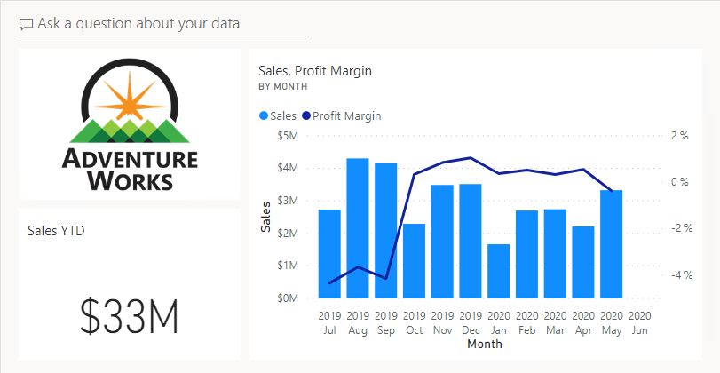

**Edit tile details**

In this task, you'll edit the details of two tiles.

1. Hover the cursor over the **Sales YTD** tile, and then at the top-right of the tile, select the ellipsis, and then select **Edit Details**.

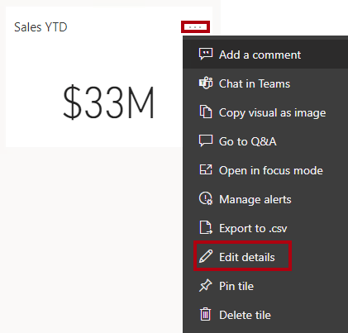

1. In the **Tile Details** pane (located at the right), in the **Subtitle** box, enter **FY2020**, and then select **Apply**.
2. Notice that the **Sales YTD** tile displays a subtitle.

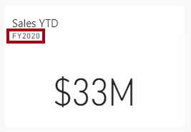

1. Edit the tile details for the **Sales, Profit Margin** tile.
2. In the **Tile Details** pane, in the **Functionality** section, check **Display Last Refresh Time**, and then **Apply**.

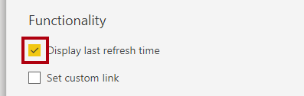

1. Notice that the tile describes the last refresh time (which done when loading the data model in Power BI Desktop).

*You’ll refresh the dataset in the next exercise. Depending on your data and report, you can do an adhoc data refresh anytime or set a schedule. However, scheduled refreshes require gateways that we aren't able to configure for this lab. So from Power BI Desktop, you'll perform a manual data refresh, and then upload the file to your workspace.*

**Refresh the Dataset**

In this exercise, you'll first load sales order data for June 2020 into the **AdventureWorksDW2020** database. You'll then open your Power BI Desktop file, perform a data refresh, and then upload the file to your workspace.

**Update the lab database**

In this task, you'll run a PowerShell script to update data in the **AdventureWorksDW2020** database.

1. In File Explorer, inside the **D:\PL300\Setup** folder, right-click the **UpdateDatabase-2-AddSales.ps1** file, and then select **Run with PowerShell**.

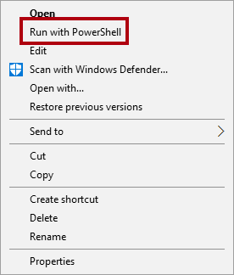

1. If prompted to change the execution policy, press **A**.
2. When prompted to press any key to close, press **Enter** again.

*The****AdventureWorksDW2020****database now includes sales orders made in June 2020.*

**Refresh the Power BI Desktop file**

In this task you'll open the **Sales Analysis** Power BI Desktop file, perform a data refresh, and then upload the file to your **Sales Analysis** workspace.

1. In Power BI Desktop file, in the **Data** pane, right-click the **Sales** table, and then select **Refresh Data**.

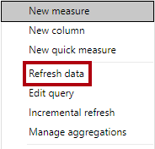

1. When the refresh completes, save the Power BI Desktop file.
2. To publish the file to your workspace, on the **Home** ribbon tab, from inside the **Share** group, select **Publish** and then select **Select** to publish.

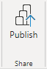

1. When prompted to replace the dataset, select **Replace**.
2. Close Power BI Desktop.

*The dataset in the Power BI service now has June 2020 sales data.*

**Review the dashboard**

In this task, you'll review the dashboard to notice updated sales.

1. In the Microsoft Edge browser window, open Power BI service, and then review the **Sales Monitoring** dashboard in **My Workspace**.
2. In the **Sales, Profit Margin** tile, in line with the subtitle, notice that the data was **Refreshed: NOW**.
3. Notice also that there's now a column for **2020 Jun**.

*If you don’t see the June 2020 data, you might need to press****F5****to reload the web browser.*

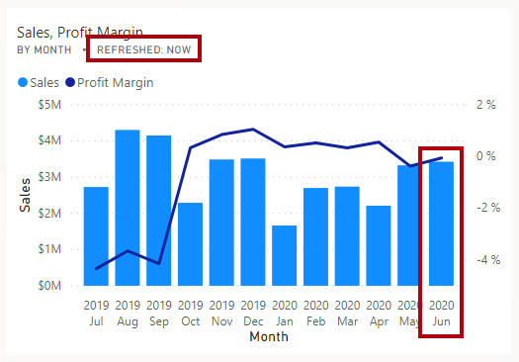

**Finish up**

In this task, you'll complete the lab.

1. Save the report and close your browser.